World premiere at Labelexpo:
Digital web-fed printing machine with integrated metallization unit

Fürth/Germany, 26 July 2017: Leonhard Kurz will present a world first at Labelexpo in Brussels from 25 - 28 September: the DM-Liner UV-Ink Built-in finishing station, integrated into a narrow-web printing and further processing machine.

This transfer station for digital metal foil from Kurz is a component of the new
Mlabel Generation 3 Mprint printing system which prints, finishes, punches and weeds labels. At the Kurz trade fair booth the full range of functionality of the Mlabel system will be demonstrated, including the trouble-free integration of the digital metal transfer step into the digital printing process.

A metallized variable design will be applied to the labels in the DM-Liner station, and then overprinted in color and further processed in the inkjet printing system. The design of the label has been selected to illustrate the unique creative possibilities of digital metal finishing, which can be used to metallize not only large areas but also filigree details. Fine cutouts and reverse types are also possible. High edge definition transfer of the digital metal foil can be achieved even at fast digital printing speeds. Visitors to the Kurz booth can take back home with them samples of the labels finished in the live demonstration.

Digital metallization also available for web-fed flexographic and web-fed offset printing

The transfer station integrated into the Mlabel machine is a built-in version of the DM-Liner UV-Ink for digital web-fed printing machines. The DM-Liner UV-Ink Roll-to-Roll is additionally available as a built-on module for web-fed flexographic printing machines, as well as a stand-alone machine. The DM-Liner UV-Ink Built-on is significantly more compact as it can utilize the corona unit, the winding and unwinding unit, edge guide controller and registration camera of the flexographic printing machine. The built-on module is mounted on a versatile mobile roller system which enables the metallization to be performed either upstream or downstream of the flexographic printing.

The DM-Liner UV-Ink Stand-alone for web-fed printing is suitable for any printing process. This unit offers an extremely flexible means of producing metallic effects on a digital, offset or flexographic printer. To produce vibrant metallic colors, for example, the print product would first be finished and then overprinted with colored ink. Variable data can be added at a later stage of production by downstream metallization. Visitors to the Kurz booth 3D40 will receive comprehensive information on the possibilities of digital metallization using the three variants of the new DM-Liner.

□□□

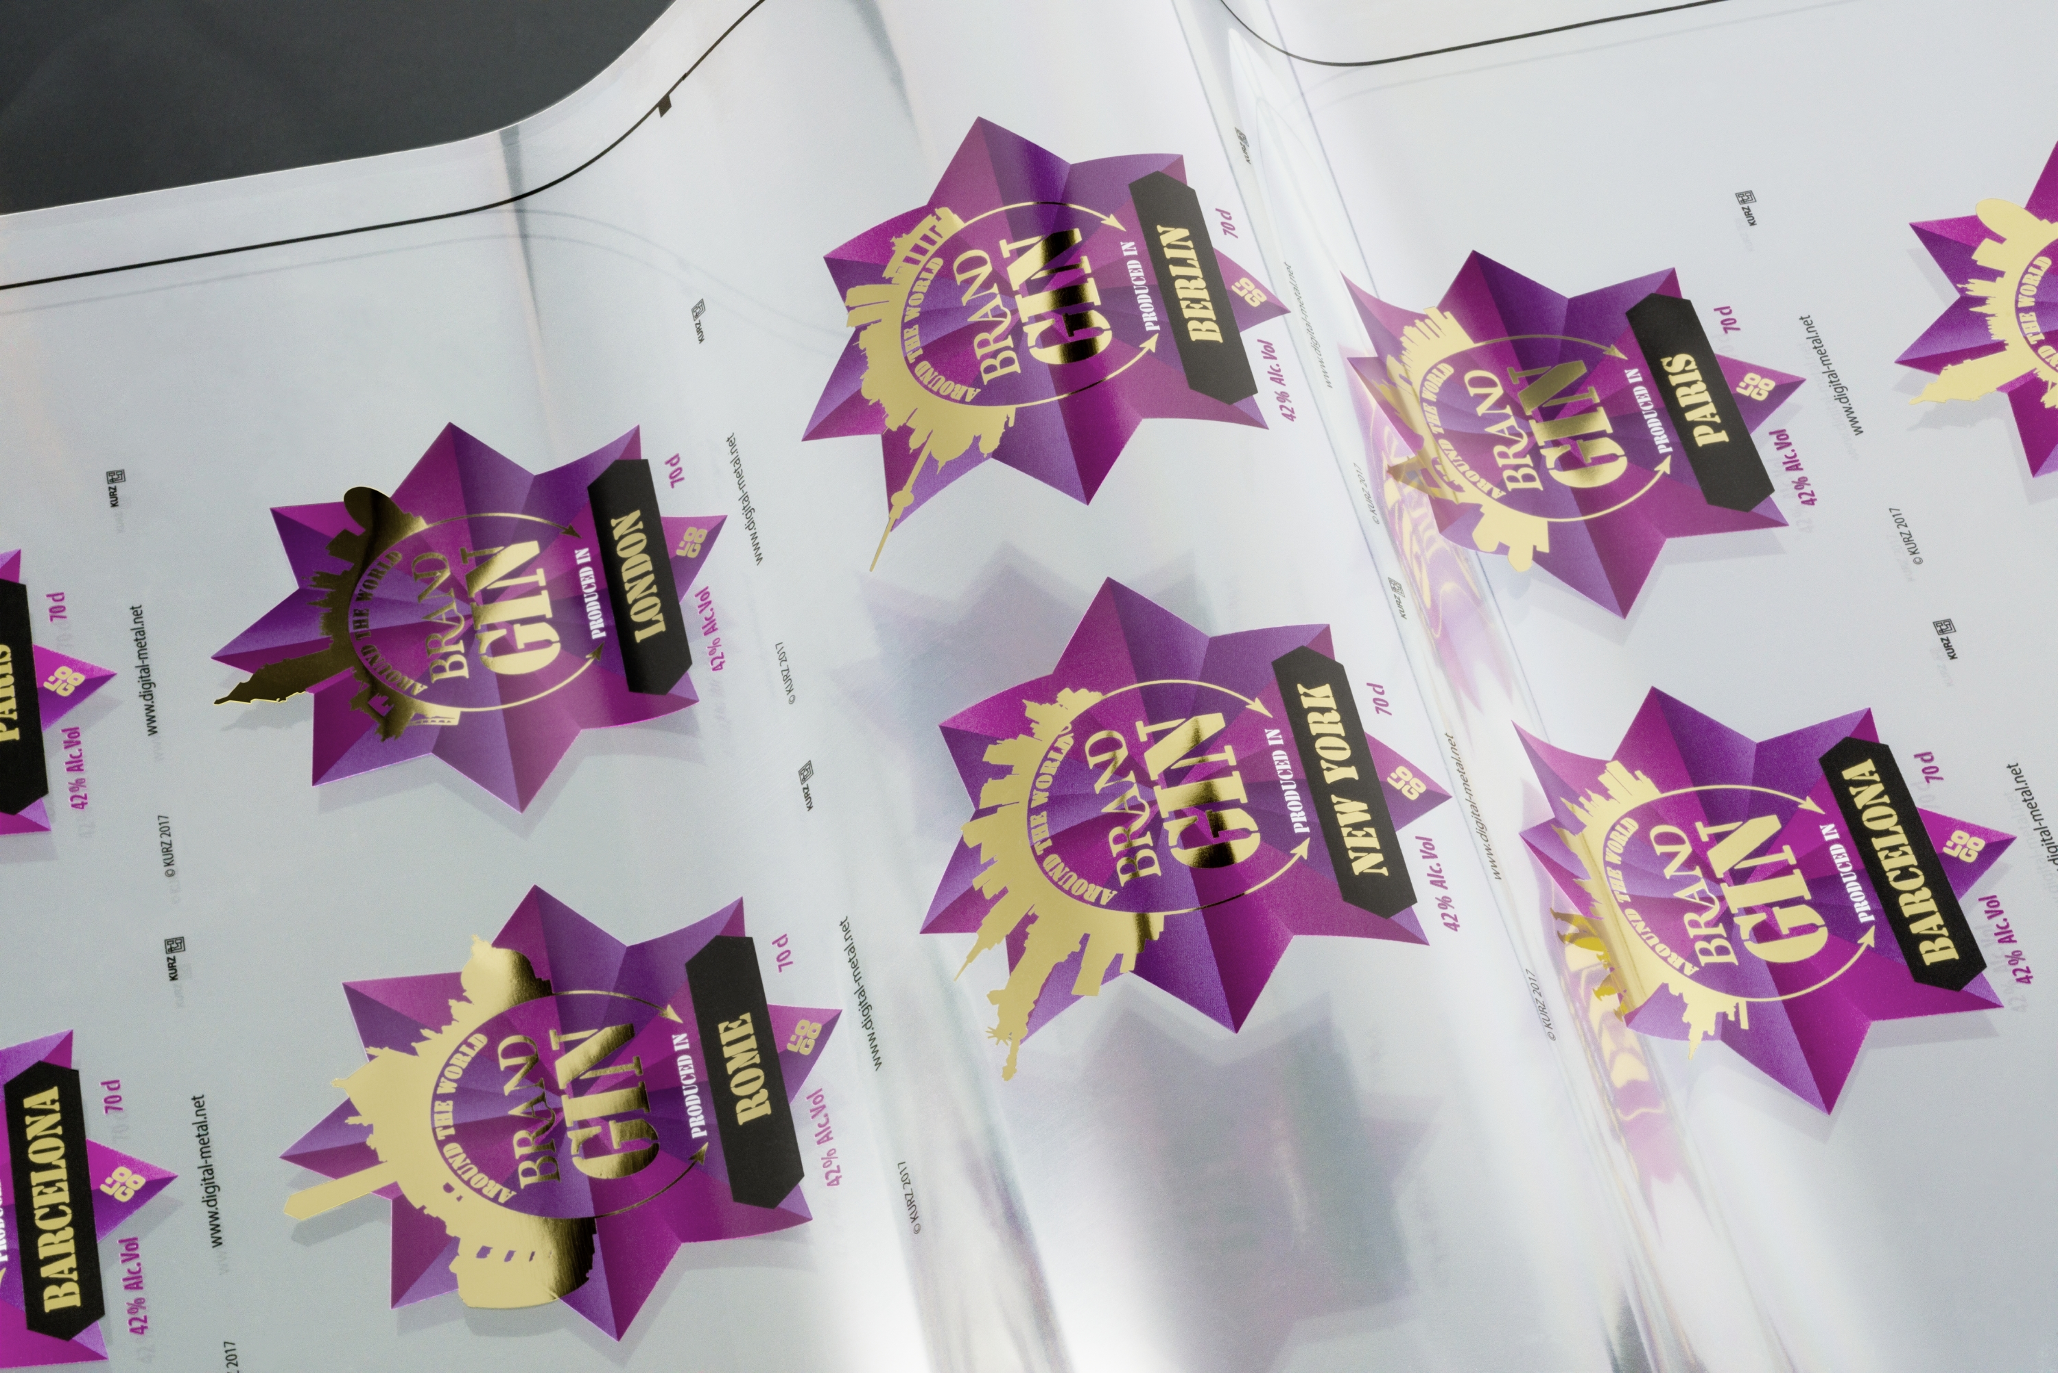
Web-fed labels finished with variable designs using Kurz DM-Liner UV-Ink technology

□□□

About KURZ: The KURZ Group is a global leader in hot stamping and coating technology. KURZ develops and manufactures decorative and functional layers applied to carrier foils for a large variety of applications. The range includes metallized, pigmented and holographic stamping foils for packaging or print products, surface finishes for electronic devices or automotive parts, protective and decorative lacquers for furniture or household appliances, authenticity features for brand name items, metallic applications for textiles, and different types of coatings for many other applications. With over 5,000 employees in twelve production plants in Europe, Asia and the USA, 24 international subsidiaries and a global network of agencies and sales offices, the KURZ Group manufactures and sells a comprehensive range of products for surface finishing, decoration, marking and counterfeit protection, rounded off by an extensive range of stamping machines and stamping tools. KURZ also continuously invests in new technologies, and is developing innovative solutions for integrating functionality into surfaces.

Press Contact:

Lucie Mengel
LEONHARD KURZ Stiftung & Co. KG
Schwabacher Straße 482, 90763 Fürth/Germany
Phone: +49 911 71 41-96 38, Fax: +49 911 71 41-96 40
E-Mail: lucie.mengel@kurz.de
www.kurz.de

